1st Assistant Production Accountant
Training Programme March 2025
Supported by Entertainment Partners

 | Course Starts:  Monday 24th March 2025
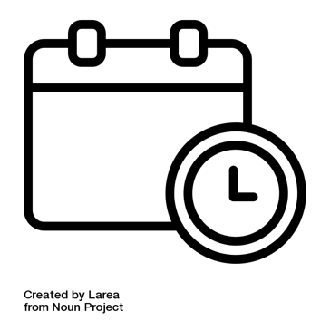 | Application Deadline:  Date: Tuesday 4th March 2024  Time: 10am

If you need support filling in this form, please contact:

  E-mail | applications@productionguild.com

1.
Personal Information


Name:

Phone number:

E-mail:


Address:

2.
More Information

 | Do you live in and are you eligible to work in the UK?
  Yes |   No | Tick or Cross here:

3.
 | What do you work on most?:  - Film  - TV  - both

4.
How did you hear about this programme? Tick or cross what applies to you and add any details:


Online/Website


Social media
Email


Other

5.
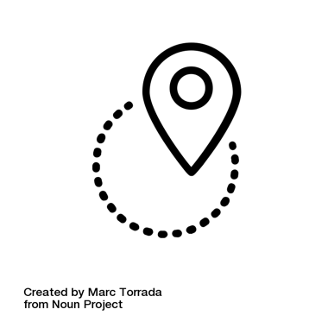 | Which region do you live in?
East of England |  | London
Midlands |  | North East & Yorkshire
North West England |  | South East England
South West England |  | Scotland
Northern Ireland |  | Outside of the UK
Wales |  | Other

6.
 | Current / latest job and duties  (500 words max)
Dates | Job Title | Duties

7.
Current / latest employer (if applicable)

Please only provide names and do not include contact details or personal data

Company name
Line Manager

8.
 | Please list your career history  Please specify at least 3 HETV or Feature Film credits and include dates, budgets and detail on your specific duties.  (500 words max)
Dates | Job Title | Production

9.
 | Please tell us:  - About your relevant experience  - Why would you benefit from this course  (250 words max)

You have now completed your Application Form.
Please return the completed form to:

E-mail | applications@productionguild.com

Please make sure that you also submit the following:
 | A Diversity Monitoring Form  - A link to this online form is on the  Production Guild website

