

Netflix Assistant Production Accountant Training Programme 2024
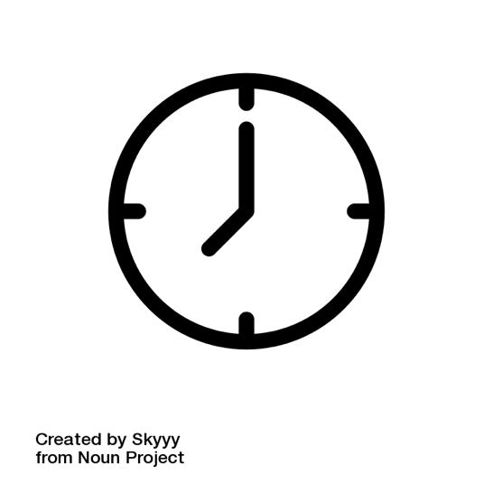 | Deadline for Applications  Date: Thursday 4th January 2024  Time: 10am
 | Netflix are looking to recruit up to ten trainees.  These trainees will need the skills and experience to work in the Netflix production accounts department.  The trainees will work on productions across the UK.
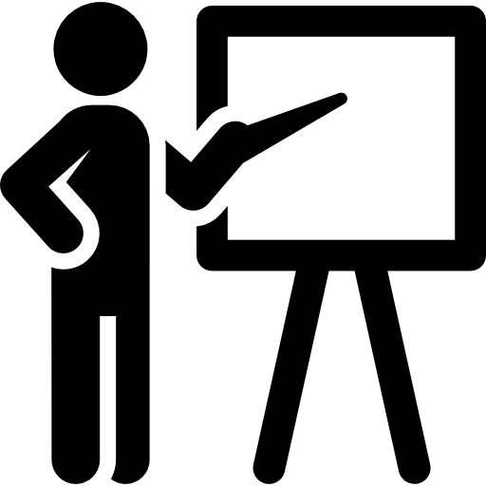 | About the training  - Trainees will complete four weeks of training to be assistant production accountants  - The training will be run by The Production Guild.  The four-week classroom training will take place in person.
 | Successful trainees will then be trained on Netflix productions over 12-months.  - Trainees will support the accounts team on productions.  - The productions could be series, film, or non-scripted.
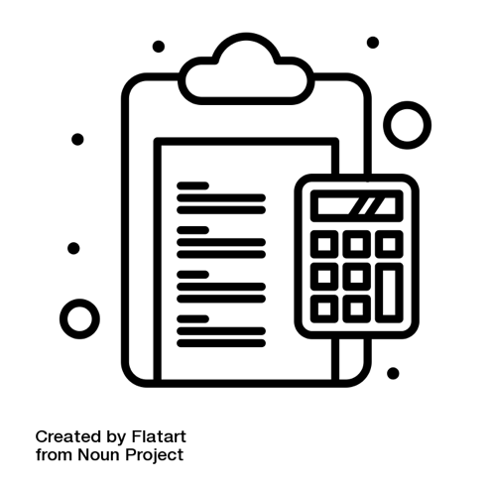 | Tasks will include:  - Sorting paperwork  - Inputting data  - Making payments  - Office administration
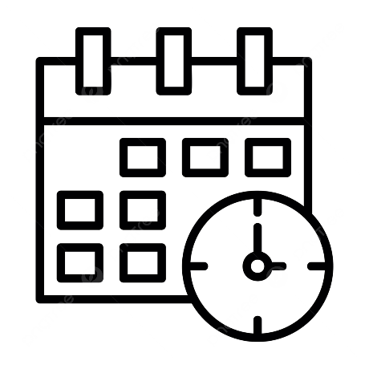 | This training programme is full time, for up to ten successful candidates.
 | At the end of the programme, some candidates may be able to keep working for Netflix productions.  - They would be working as a freelancer in the production accounts department.
 | Applicants need to have either:  - Qualifications in accounting  Or  - Relevant work experience  - For example, working in administering finances.
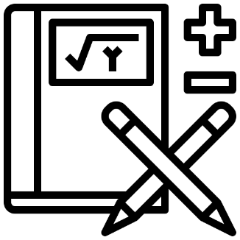 | Applicants need to be confident with numbers and figures.
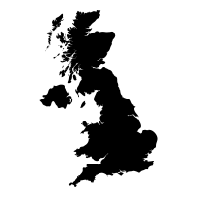 | Applicants must have a permanent address in the UK.  Applicants must be eligible to work in the UK.
 | What do I need to consider before applying ?  - You will be starting your career as an Assistant Production Accountant in a trainee/junior role.  - The UK film and television industry can be unpredictable.  - Working as a freelancer means that there is no guarantee of work after the training programme.
The hours are long.

  - You will be working a minimum 55-hour week.
  - Sometimes you will work six days per week.
 | - For the first four weeks of classroom training, you will be based in the Leavesden area.  - For the production placements, you may be based anywhere in the UK.  - You must be happy to travel or relocate to wherever the production takes place.
 | Payment:  - You will be paid £728.31 per week (including taxes) for the whole of the programme.  - This includes  - The classroom training  - While contracted to the Netflix productions.
Payment:
- After the training, we suggest you could earn £750.00 per week (including taxes).

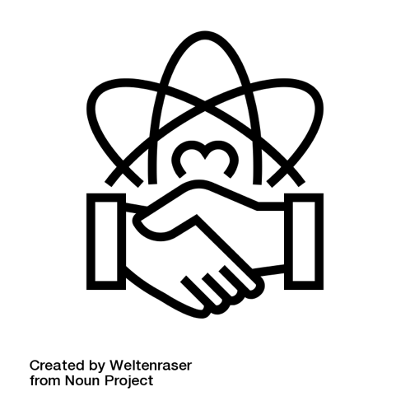 | Code of Conduct  - Everyone who applies for the programme agrees they will commit to the Production Guild’s code of conduct.  - The code of conduct can be found at:  http://productionguild.com/about-pggb/our-code-of-conduct
 | Tests  Between 15th January and 17th January, everyone who has been invited to interview will take tests in:  - Maths  - Microsoft Excel  The tests will be on Zoom.

 | Interviews  Interviews will be via Zoom between:  - Wednesday 17th January – Friday 19th January 2024
   | Offers  - We will aim to offer places on the programme (after checking references) the week starting 22nd January 2024.  - The programme will officially begin on Monday 26th February 2024.

