

Netflix Assistant Production Accountant Training Scheme 2026
In partnership with Netflix, we are proud to launch the newest iteration of our Assistant Production Accountant Training Scheme (NAPATS).

The 2026 scheme is designed for Deaf, Disabled, or Neurodivergent (DDN) accountants transferring into the film and TV industry.

The 12-month paid programme offers the chance for up to 5 trainees to

- Increase knowledge and skills through classroom-based training

- Build hands-on experience through placements on Netflix productions.

 | Other accessible versions of this page:  BSL page content  Audio page content
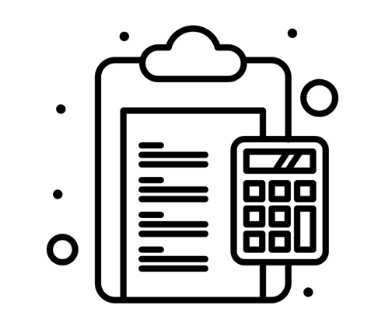 | What is an Assistant Production Accountant?  The role supports the Production Accounts team members on  - Payroll  - Petty cash and purchasing cards  - Accounts payable
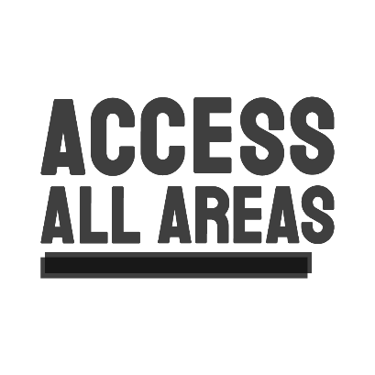 | Access  Supported by Access all Areas  Contact access@productionguild.com to arrange a confidential conversation.  You are welcome to let us know about any access requirements for applications or interviews, but you do not need to.
 | At the end of the programme, some candidates may be able to keep working for Netflix productions.  They would be working as a freelancer in the production accounts department.
 | To apply  Please read the Application Pack and Frequently Asked Questions below, there will tell you how to apply.  Contact applications@productionguild.com with any other questions.
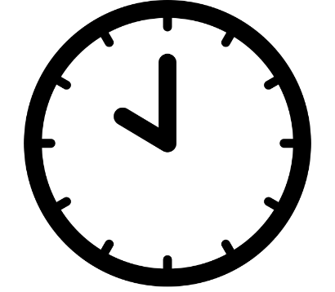 | Deadline  Tuesday 4th November  10.00am GMT
 | Application Pack  The Application pack has  - Information about the programme  - Guidance for applying  Different formats  - Word Doc pack  - Plain text pack  - PDF pack  - BSL pack  - Easy Read pack  - Audio pack
 | Completing your Application Form  There are 12 questions  You will be asked to refer to the Trainee Specifications in the Application Pack  To apply you can  - Fill in the online Microsoft form  - Complete and send one of the different formats below  - Record and send an audio or video file with answers to the questions  You must read the Application Pack before applying
Application Form

Different formats
- Online Microsoft form
- Plain text form
- Word doc form
- BSL form
- Easy Read form
- Audio form

 | Equal Opportunities Form  It would be helpful for us if you could also complete and send this.  Answers are anonymous and will not affect your application.  You do not have to do this if you would prefer not to.  Email access@productionguild.com for support filling this in.  Fill in the Equal Opportunities Form here.
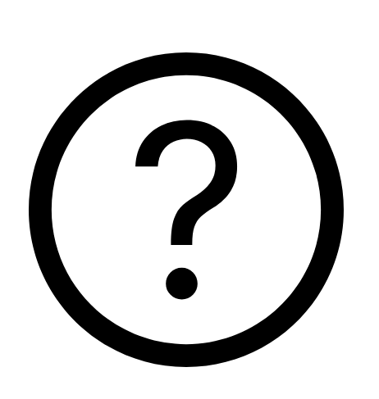 | FAQs  Different formats  - Word doc FAQs  - Plain text FAQs  - PDF FAQs  - BSL FAQs  - Easy Read FAQs  - Audio FAQs
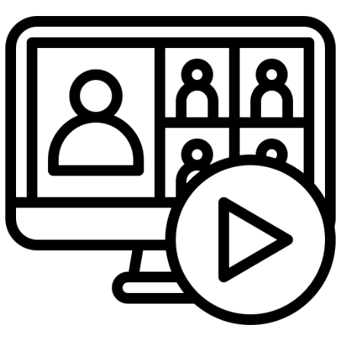 | Webinar  We are holding a webinar on  Thursday 25th September at 1.00pm-2.00pm.  We’ll share  - Information about the course from The Production Guild  - Information about placements from Netflix  - Information about access and support by Access All Areas.  - There will be subtitles and a BSL Interpreter present.  - There will be an opportunity to ask any questions.  To join the webinar, register here.  After 25th September, a recording of the webinar will be available to watch here

