

Netflix Assistant Production Accountant Training Scheme 2026
Application Pack
Contents
- Introduction |  | Page 2
- Programme Overview |  | Page 3
- Trainee Requirements |  | Page 13
- Recruitment and Selection Process |  | Page 18
- How to Apply |  | Page 24
 |  | Accessible versions of this application pack are available on our website and through these links  Word Doc pack  Easy Read pack  Plain text pack  BSL pack  Audio pack
- Introduction
 |  | Thank you for your interest in the Netflix Assistant Production Accountant Training Scheme 2026.  This pack will give you information on  - The programme  - Who can apply  - The recruitment and selection process  - How to apply.  Please read this pack before applying. It includes important information for your application.
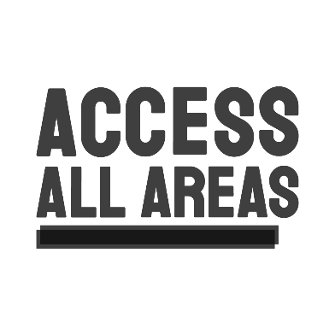 |  | If you would like to have a confidential conversation with the Access Coordinator before applying, please email access@productionguild.com  - We can put you in contact directly with an Access Coordinator from Access All Areas  - They can provide access support with the application.  - Any conversations with Access All Areas can be kept private and confidential.  - You are welcome to let us know about any access requirements for applications or interviews, but you do not need to.
- Programme Overview
In partnership with Netflix, we are proud to launch a new paid training programme for Deaf, Disabled, or Neurodivergent (DDN) accountants to work in film and High End TV (HETV).
This 12-month paid programme offers the chance for up to 5 trainees to
- Increase knowledge and skills through classroom-based training
- Build hands-on experience through placements on Netflix productions.
Access support will be available throughout the programme.
 | Trainees will undertake  - 5 weeks of paid training  - 11 months of paid placements on Netflix productions.  You will learn how to become an Assistant Production Accountant
 | At the end of the programme, there could be an opportunity for candidates to continue working for Netflix productions as freelancers in the production accounts department.
 | Dates of the programme  Between February 2026 - February 2027
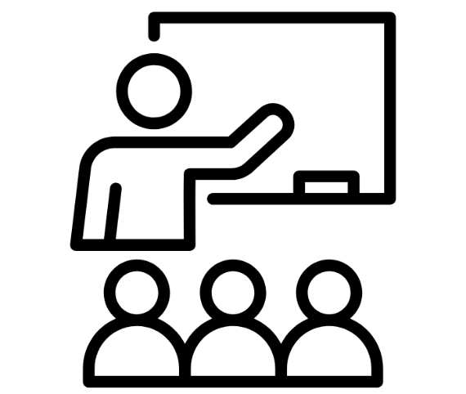 | Training  25th February - 27th March 2026  21 days of paid training sessions over 5 weeks.  - Training days run 9.30am - 5.00pm.  - Each day will have 4 training sessions.  - Training sessions are roughly 1.5 hours each.  - There will be breaks between each session and 1 hour for lunch.
Dates for each training week
 | Week 1  Wednesday 25th February - Friday 27th February  3 days training  Week 2  Monday 2nd March  Tuesday 3rd March  Thursday 5th March  Friday 6th March  4 days training - no training on Wednesday 4th March  Week 3  Monday 9th March - Friday 13th March  5 days training  Week 4  Monday 16th March  Tuesday 17th March  Thursday 19th March  Friday 20th March  4 days training - no training on Wednesday 18th March  Week 5  Monday 23rd March - Friday 27th March  5 days training
 | Training placements on Netflix productions  March 2026 - February 2027  Placements will either be on  - Film  - Series
 | Duties  The role of the Assistant Production Accountant is to support the Production Accounting team members who are leading on payroll, petty cash and purchasing cards, and accounts payable.
 | For more detail please refer to the ScreenSkills job description here.
Work Pattern
The Assistant Production Accountant role can be one of the more accessible roles in film and TV.

- It is often based in a consistent place, such as an office in a film studio
- For this scheme trainees will be at Shepperton or Longcross Studios
- Days worked tend to be Monday to Friday
- The hours are regular, but can sometimes have flexibility
- Your working hours are not always lined up with the shoot schedule
- You are not required to work additional hours that may be required of the shooting crew, such as night shoots

 | Before applying to this programme, it is also worth considering the points below.  - You will be starting your career as an Assistant Production Accountant in a trainee or junior capacity regardless of previous experience.  - The UK film and television industry can be unpredictable.  - Netflix cannot guarantee work following the placement.  - Working as a freelancer means that income can be inconsistent.
 | During placements you will be working hours that match the production you’ll be working on.  Working hours on productions can be long.  We recognise that long hours are not accessible for everyone.  Each trainee can discuss working hours with an Access Coordinator and adjustments can be made as needed
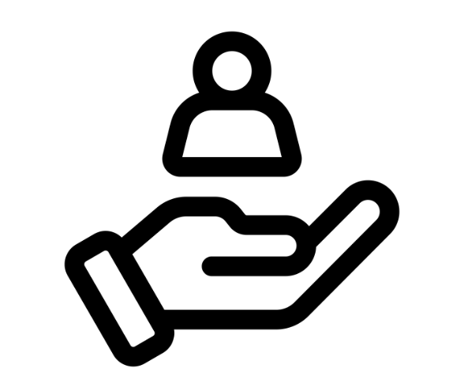 | We will offer support through this programme to help you work in the industry in an accessible way.  This could include  - Supporting you to develop an Access Passport or “Work With Me” plan, to help you articulate any adjustments you need for future work.  - Guidance on how to approach conversations on flexible working hours.  - Links to resources and networks that can give guidance and support to production companies on how to create accessible work environments.  If you require a flexible working pattern for access reasons, this will not impact your eligibility for this training programme.
 | Payment  If selected, you will be paid the London Living Wage plus holiday for the duration of the training and placement.  Holiday pay will be withheld and stored until the end of the contract if no holiday is taken.
 | After finishing of the programme there may be an opportunity to continue working for Netflix.  As a general guide, we suggest graduates of the programme could earn a starting salary of around £750 per week (gross).  This includes holiday pay, which is withheld and accumulated until the end of the contract if no holiday is taken.  This weekly rate will then rise gradually with experience.
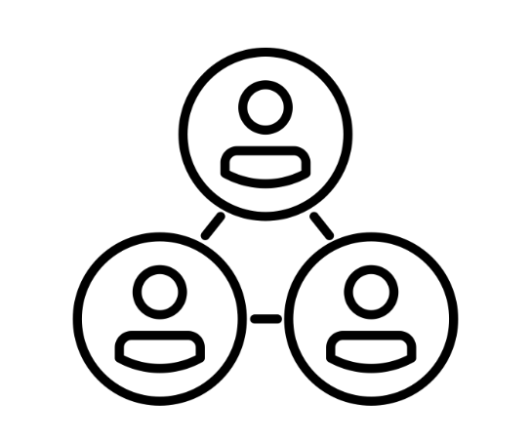 | Programme Team  The programme will be led by industry-leading organisations and talent including:
The Production Guild of Great Britain (PGGB)
- Organising the training
- Main point of contact during the application process

Netflix
- Collaborating on the scheme in partnership with PGGB since 2018
- Organising and managing placements
- Providing mentorship with an experienced industry mentor throughout the placements

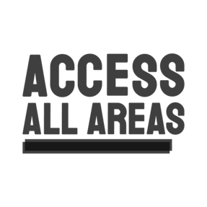 | Access All Areas  - Access Coordinators  - Available to confidentially support with applications  - Available to provide access support and advice throughout the programme
 | Bex Scott  - Leading the 5 weeks of classroom training  - Financial Controller with lived experience of having a chronic illness and being Neurodivergent
Industry experts
- Guest speakers deliver specific sessions during the training course

- Trainee Requirements
You will be asked to outline how you meet these requirements in the Application Form.
Applicants must
- Have a permanent UK address
- He eligible to work in the UK.

Availability
Applicants should
- Be available for the tests and interviews between Monday 1st December and Friday 5th December 2025

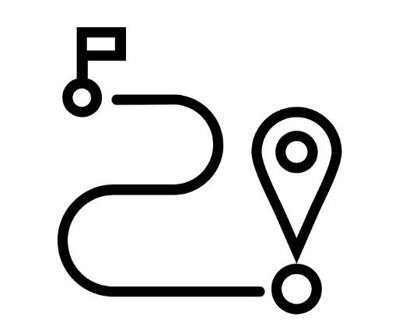 | Travel  - Be open to travelling to Shepperton Studios for the 21 training days between Wednesday 25th February and Friday 27th March  - Be open to travelling to Shepperton or Longcross Studios every day for the whole placement between March 2026 - February 2027
 | Accounting Skills and Experience  You will be asked to outline how you meet these requirements in Question 10 of the Application Form.  Applicants should  Understand and/or have practical experience in at least one of the following areas  - Running and processing payroll  - Setting up and monitoring systems for invoices  - Bookkeeping  - Setting up and running petty cash systems.
   | Have academic or professional qualifications in accounting, or a similar level of skills through work experience.  Relevant experience might include:  - Work as a cashier,  - Work as a bookkeeper  - Junior financial administration work
 | Personal Attributes  You will be asked to outline how you meet these requirements in Question 10 of the Application Form.
We welcome applicants who
 | Identify as Deaf, Disabled and/or Neurodivergent, or have a chronic health condition
 | Be committed to a career in accounting in film and TV
 | Take a proactive approach to learning whilst on the programme
 | Be skilled in IT, including Excel or Google Sheets
 | Be self-motivated and are able problem solve during challenges
 | Be able to work as part of a team
 | Be able to work to deadlines
 | Be able to ensure their work is always accurate at the point of completion
 | Be willing to work positively and constructively with a wide range of people, from the most junior to the most senior members of the production
 | Be happy to work in a fast-paced environment, provided access requirements are met
   | Understand and uphold the highest professional attitudes and business ethics.
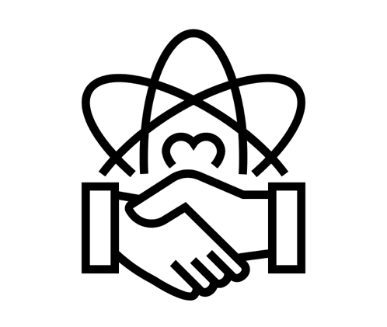 | By applying for this programme, you are committing to uphold the Production Guild’s code of conduct.  - Details on the Code of Conduct can be found here.  - PGGB reserves the right to decline any applicant who is found not to meet those professional standards.
- Recruitment and Selection Process
Dates of recruitment process
Tuesday  4th November 2025  10am | Application deadline
Wednesday  12th November 2025 | Email sent inviting candidates to interviews
Wednesday  19th November 2025 | Deadline to respond to invitation to interview
Monday - Thursday  1st - 4th December 2025 | Interview Tests
Tuesday - Friday  2nd - 5th December 2025 | Interviews
Monday  8th December 2025 | Places on course offered by
Monday - Monday  8th -15th December 2025 | References contacted
Tuesday  16th December 2025 | Places on course confirmed by
Wednesday  25th February 2026 | Course starts
Interview Tests
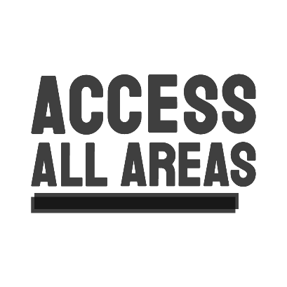 | You will have the opportunity to talk to an Access Coordinator about your access requirements before the interview tests and interviews, as well as before the course.
 | Interviewees will take the two tests.  These are usually held via Zoom, but can be held in person at Shepperton Studios if a candidate prefers this for access reasons.  These will be run between  Monday 1st - Thursday 4th December 2025  The tests will likely cover  - Maths  - Microsoft excel
Interviews
 | Interviews will usually be held via Zoom, though can be held in person at Shepperton Studios if a candidate prefers this for access reasons.  These will be run between  Tuesday 2nd - Friday 5th December 2025  During the interviews, candidates will talk with a team of people from Netflix.  We will send photos, names and job titles of those on the panel to candidates in advance.
 | We will schedule 30 minutes for each interview, depending on access requirements.
 | One of our team of Access Coordinators will be available to support on the day and to help you settle in before your tests and interview.
 | If you are invited to the interview stage, we will send you more information about what to expect from the tests and the interviews on the day.

Offers of Places
 | We will aim to offer places on the programme by Monday 8th December 2025.  This offer will be subject to references.  Once an offer has been accepted we will then contact references between Monday 8th - Monday 15th December 2025.
 | We will confirm places on the course by Tuesday 16th December 2025.
 | We will arrange for each trainee to talk to our Access Coordinator in early January, before the course starts, to discuss access requirements.
 | The programme will formally begin on Wednesday 25th February.
Access
You are welcome to let us know about any access requirements for applications or interviews, but you do not need to.

If you would like to have a confidential conversation with the Access Coordinator before applying, please email access@productionguild.com

We can put you in contact directly with an Access Coordinator from Access All Areas

Any conversations with Access All Areas can be kept private and confidential

You will have the opportunity to talk to an Access Coordinator about your access requirements before the interview tests and interviews, as well as before the course.

The Access Coordinator will support you to develop an Access Passport or “Work With Me” plan, to help you articulate any adjustments you need.

The Access Coordinator will continue to support everyone’s access requirements throughout the course and the placements.

They will provide links to resources and networks that can give guidance and support to production companies on how to create accessible work environments.

- How to Apply
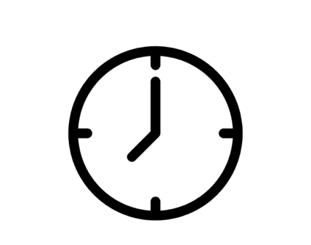 | Deadline  Tuesday 4th November 2025  10am GMT
 | To apply, please  - complete an Application Form (links below)  - email it to applications@productionguild.com, or use the online form  - use the subject line ‘NAPATS 2026 - Application’.  If possible, please also complete an Equal Opportunities Form.  This is anonymous and will not affect your application.
Application Form

The Application Form has 12 questions. In your answers, you will be asked to refer to the Trainee Specifications from this Application Pack to show how you are suited to the role.

The Application Form is available in different accessible formats.

To apply, you can either
- fill in the online Microsoft Form here
- complete and send one of the forms below, or
- record and send an audio or video file with your answers to the questions.

Online Microsoft Form
Word Doc form
Easy Read form
Plain text form
BSL form
Audio form

If you would like any of the above documents sent to you directly, please email applications@productionguild.com
Additional evidence such as CVs, copies of certificates, references, etc. will not be considered. Please do not include them with your application.

Below you will find more information about how to answer each question.
 | Question 1-5  - Please include answers to all the questions.  - Where there is a YES/NO answer, please delete either YES or NO.  - If your contact details change for any reason, please tell us by emailing applications@productionguild.com
Question 6 - Education, Training and Qualifications

List all your educational and training achievements that are relevant to your application.

Please start with your most recent achievement first.

We are interested in any vocational training you have done.

We are also interested in any formal or informal training you have taken outside the world of work.

Question 7 - Work Experience

Please list all your work experience.

Please start with your most recent work experience first.

Please include
- Start and end dates
- Details of your employer
- Your job title
- A short description of your job duties and annual pay if applicable.

 | Question 8 - What would you like to achieve from taking part in this programme?  We’d like to hear what you would like to get out of the programme directly  - eg. good understanding of payroll.  We’d also like to hear where you’d like this to take you  - eg. career in production accounting on a scripted series.
Question 9 - Please explain an example of a work situation in which you have demonstrated logical problem solving and organisational skills.

We would like you to state the situation, what your actions were, and tell us what the result was.

Question 10 - Please provide details of how your Accounting Skills, Experience and Personal Attributes meet those listed in the Trainee Requirements.

To answer this question please refer to this Application Pack, specifically Section 3 - Trainee Requirements.

Please use real life examples to demonstrate this.

We would encourage applicants to address each Trainee Requirement.

Please note that while you do need to identify as Deaf, Disabled, Neurodivergent or having a chronic health condition to be eligible for this programme, you do not need to tell us how.

Question 11 - It’s important to us that you have a passion for TV and film. Please answer the following questions

- Why do you want to work in the TV and film industry?
- What kind of production would you like to work on? eg. Comedy, Drama.
- What is your favourite Netflix show and why?

This question is an opportunity to tell us why you are passionate about film and TV.

We would like to hear personal answers and find out where your interests lie.

 | Question 12 - References  Please give us the details of two referees.  One reference must be from your current or last employer.  The second reference should be able to comment on how your skills might be suited to this training programme.  Please note that we will not contact your references unless you are offered a place on the programme.
 | Equal Opportunities Form  It would be helpful for us if you could also complete and send the Equal Opportunities Form. Answers are anonymous and will not affect your application.  You do not have to do this if you prefer not to.  If you would like support filing this in, please email  access@productionguild.com  and we can put you in touch directly with our Access Coordinator for confidential access support.  Link to Microsoft form here.
 | We wish you the very best of luck with your application. Please do reach out to us with any questions and we will do our best to reply as quickly as possible.

